

VIETNAM NATIONAL UNIVERSITY, HANOI
INTERNATIONAL SCHOOL

LOGISTIC MANAGEMENT SYSTEM

Subject’s Name : Data structures and algorithms
Class : INS305005
Instructor : PhD Diêm Công Hoàng
Members : 1. Giang Thùy Trang – 22070945
2. Nguyễn Quỳnh Chi – 22071081
3. Bùi Minh Đức – 22070952
4. Tô Ngọc Minh Trâm – 20070883

Hanoi, 2025
Table of Contents
I. INTRODUCTION 5
1. What is the Topic? 5
2. Why choose the topic. 6
3. Objective of the topic 7
3.1. Functional 7
3.2. Technical 8
II. IMPLEMENTATION METHODOLOGY AND TOOLS 9
1. Development Methodology 9
2. Tools and Technologies 9
III. DESIGN 10
1. Library used 10
2. Definition of Constant 10
3. Data Structures 11
4. Global variables 14
5. Login System 14
6. Main Funtion 17
6.1. User management 17
6.2. Inventory Management 18
6.3. Order Management 21
6.4. Vehicle Management 24
6.4. Route & Delivery Management 26
6.5. Reports and Statistics 28
6.6. Search and Filter 29
IV. RESULT 33
V. CONCLUSION 36

CONTRIBUTION

Name | ID | Contribution
Giang Thùy Trang | 22070945 | 25%
Bùi Minh Đức | 22070952 | 25%
Nguyễn Quỳnh Chi | 22071081 | 25%
Tô Ngọc Minh Trâm | 20070883 | 25%

INTRODUCTION

What is the Topic?
In the context of rapid digital transformation, logistics management has emerged as a critical component in the operational success of e-commerce platforms. The efficiency and reliability of logistics directly influence customer satisfaction, delivery speed, inventory control, and overall business competitiveness. With this in mind, the project titled "Management Logistic System" is developed as a simulation of a simplified logistics system tailored for online shopping websites.
This project aims to replicate the fundamental operations involved in e-commerce logistics, including the management of warehouse inventory, processing and tracking of customer orders, organizing delivery routes, and assigning delivery personnel (shippers) to ensure timely delivery of goods. It is designed to provide both a practical solution and an academic model for understanding how basic logistics processes function in an online business environment.
The system is implemented using the C programming language, known for its performance and control over system-level operations. To efficiently handle dynamic data and ensure ease of navigation through records, the project extensively utilizes the Doubly Linked List data structure. This allows for bi-directional traversal, insertion, and deletion of elements, making the system more flexible and responsive to real-time changes in logistics operations.
The core functionalities of the logistics management system include:
- Managing warehouse inventory, such as adding new products, updating stock levels, and removing items.
- Creating and tracking customer orders from placement to delivery.
- Planning and organizing delivery routes for optimal efficiency.
- Assigning delivery staff (shippers) to orders based on availability and route compatibility.
- Searching for and displaying detailed information on products and orders.
This project not only serves as a practical application of theoretical computer science and data structure concepts but also mirrors real-world scenarios that occur in the logistics operations of modern e-commerce businesses. By simulating these processes, students and developers can gain valuable insights into the design, logic, and challenges of building logistics systems in a digital commerce environment.

Why choose the topic.
In real-life operations, managing logistics—such as tracking inventory, handling orders, organizing deliveries—is often done manually or through disconnected tools like spreadsheets, paper notes, or non-integrated apps. These methods can easily lead to confusion, data loss, delayed deliveries, or duplicated work. This is especially common in small and medium-sized businesses or online sellers who haven’t invested in a professional logistics solution.
That’s why we decided to build a simple but structured logistics management system, applying what we’ve learned about doubly linked lists and data structures in C. Our goal was to simulate how a real logistics system works in software form. Even though it’s a basic version, the system helps organize information better, track operations clearly, and support faster decision-making.
By digitizing logistics, businesses can gain huge benefits in both efficiency and cost savings. When everything is stored, linked, and processed systematically, companies save time, reduce human error, and improve customer satisfaction thanks to faster and more reliable service.
This kind of system could be useful in many situations, such as:
- Transport companies managing shipments and delivery staff.
- Retailers and e-commerce businesses tracking stock and processing customer orders.
- Small online stores looking for a simple tool to manage orders and deliveries.
In summary, we chose this topic because it is practical and relevant to today’s business needs. It also allowed us to apply our academic knowledge to something close to real-world challenges. Developing this system helped us learn more about software design, data handling, and the logic behind real logistics platforms.

Objective of the topic
The purpose of this project is to build a simplified but functional logistics management system that simulates how a real-world logistics platform operates.
The goals of the system can be divided into two categories: functional goals and technical goals.

3.1. Functional
The system is designed to support the core functions required in managing logistics operations. These include:
- Order Management:
  - Create new customer orders.
  - Track and update the status of existing orders.
  - Link each order with its corresponding product and delivery information.
- Inventory Management:
  - Add, update, or remove product information.
  - Monitor stock levels to avoid overstock or stockouts.
  - Allow users to view product details easily.
- Delivery and Route Management:
  - Define and store delivery routes.
  - Track which orders are assigned to which delivery routes.
  - Optimize delivery efficiency through route management (in future expansion).
- Shipper Assignment:
  - Maintain a list of delivery personnel.
  - Assign shippers to specific orders and routes.
  - Keep records of delivery tasks per shipper.
- Search and Reporting:
  - Provide search functions for orders, products, and shippers.
  - Allow users to generate simple reports, such as order summaries, stock levels, and delivery history.

3.2. Technical
On the technical side, the system also aims to achieve several key objectives:
- Implementation in C: The entire system is built using the C programming language, focusing on low-level memory management and the use of doubly linked lists to store and navigate data efficiently.
- Use of Data Structures: Implement custom data structures such as doubly linked lists to manage dynamic sets of data like orders, products, and shippers, without relying on built-in libraries.
- Modular Design: Organize the code into separate modules for each functional area (orders, products, routes, shippers) to ensure readability and maintainability.
- Security Considerations (Basic): While full-scale authentication or encryption is not implemented (as this is an academic project), the system ensures data integrity within the program by validating user inputs and controlling access to modification functions.
- Console-Based User Interface: Develop a simple, user-friendly text-based menu interface that allows users to interact with the system without requiring external tools or libraries.

IMPLEMENTATION METHODOLOGY AND TOOLS

Development Methodology
This project follows a modular and incremental development approach. Each function of the logistics system (e.g., order management, inventory tracking, shipper assignment) was designed and implemented as a separate module using C. This helped ensure:
- Code organization: Easy to read, test, and debug.
- Independent functionality: Modules can be developed and tested separately.
- Scalability: New features can be added with minimal changes to existing code.
We used Doubly Linked Lists (DLL) as the core data structure for managing dynamic records, such as orders, products, routes, and delivery personnel. DLLs offer efficient traversal in both forward and backward directions, which is useful for updating, deleting, or viewing data in sequence.

Tools and Technologies
Tool/Technology | Purpose
C Programming | Main language for system implementation
GCC Compiler | To compile and run the C source code
VS Code or Code::Blocks | Development Environment (IDE)

DESIGN

Library used
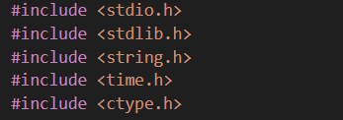
These are the standard libraries used in the program:
stdio.h: Supports basic input/output functions such as printf, scanf, getchar, used to communicate with users via the console screen.
stdlib.h: Provides functions related to memory management, type conversion and calling operating system commands such as malloc, free, exit, system().
string.h: Provides string processing functions such as strcpy, strcmp, strlen, which are essential for processing names, passwords, directories, etc.
time.h: Supports time operations, such as getting the current date and time or date format.
ctype.h: Provides character checking functions such as isdigit, isalpha

Definition of Constant
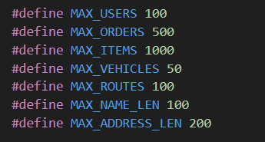
These constants are used to limit the size of key data arrays in the program. For example, the system can only contain a maximum of 100 users (MAX_USERS), 1000 products (MAX_ITEMS), or 500 orders (MAX_ORDERS). This limit helps prevent memory overflows and makes the program more manageable.

Data Structures
In this program, struct data structures are used to model entities in logistics management systems such as users, products, orders, vehicles, and delivery routes. This is the foundation for storing and manipulating data.

- User
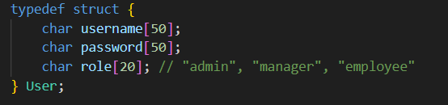
User is an object that represents a user of the system.
The username attribute is the login name.
Password is the password.
Role defines the user's permissions, such as "admin", "manager", or "employee". This role will affect the functions that the user is allowed to access.InventoryItem

- InventoryItem.
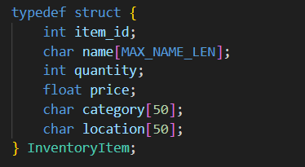
Represents an item in the warehouse.
- item_id is a unique code.
- name is the product name.
- quantity is the current quantity in stock.
- price is the selling price.
- category is the product group.
- location is the physical location in the warehouse.
This type of data will be used in operations to display, add, search and update the warehouse.

- Order
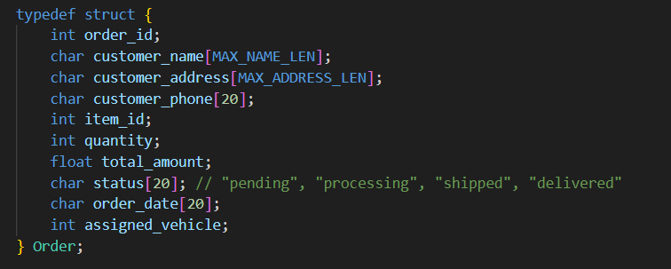
An order represents a customer order. An order stores information such as the customer name, address, ordered products and quantities, total payment amount, status (e.g. "pending" or "delivered"), order date, and delivery vehicle code. This structure is used in order management and processing.

- Vehicle
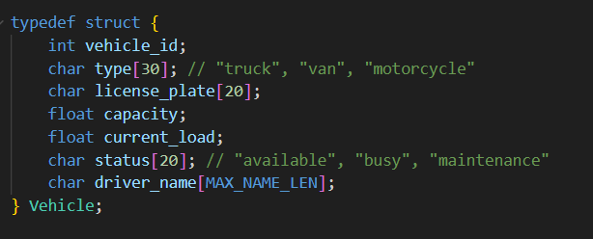

The Vehicle structure describes the delivery vehicle. Each vehicle has a vehicle_id, type, license_plate, capacity, current_load, status, and driver name. The system uses this information to distribute orders and plan routes.

- Route
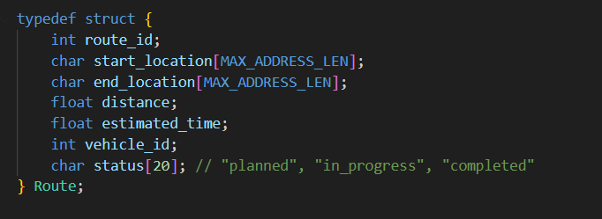
Route models a delivery route, including origin, destination, distance, estimated time, assigned vehicle, and current route status (planned, in progress, or completed).

Each of these structures is designed to realistically reflect real-world logistics operations, from warehousing, sales, shipping, to status tracking. Each part of the program interacts with these structures to perform specific functions such as displaying, adding, editing, and deleting data.

Global variables
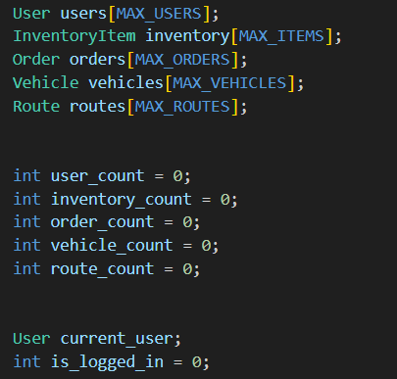
Global variables such as: users, inventory, orders, vehicles, routes are arrays used to store information corresponding to each defined data structure type.
Variables user_count, inventory_count,... are used to count the number of elements currently in each list.
Variable current_user stores the current user after logging in, and is_logged_in is a flag to check the login status.

Login System
The login system in the program consists of two main functions: login() and authenticate_user(). This is the core part to authenticate users before accessing the system.

    - Authenticate_user() function
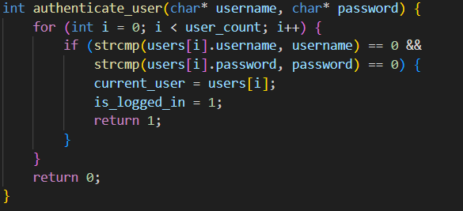
- The for loop iterates through the entire list of users in the system (data stored in the users[] array).
- strcmp() is used to compare the username and password strings.
- If a matching account is found:
- Assign the user information to current_user (a global variable that stores the logged-in user status).
- Set the is_logged_in flag to 1 to mark that the login was successful.
- Returns 1 (true).
- If no matching account is found after all the searches, returns 0 (false).

    - Login() function
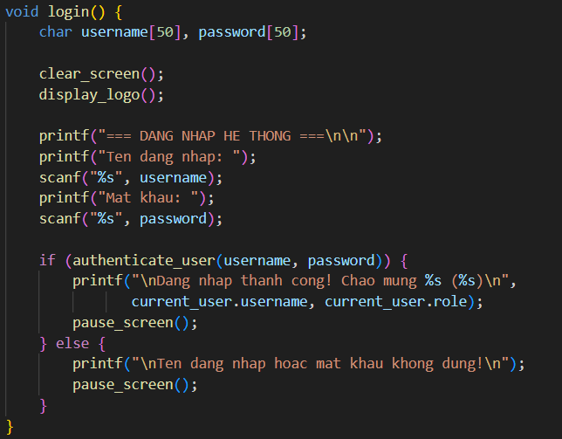
The clear_screen() function clears the screen for a new display.
display_logo() displays the program logo or title.
The user is asked to enter a name and password.
Call authenticate_user() to check the validity of the account.
If true, the login is successful.
If false, the failure message is displayed and a retry is requested.

- How it works in main()
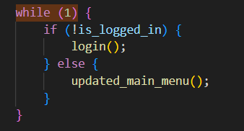
- Each time the program runs, the main loop checks the is_logged_in status.
- If not logged in, call the login() function.
- If logged in, go to updated_main_menu() to use the management functions.

Main Funtion

6.1. User management
There are 3 user roles: admin, manager, employee.
Features:
- User login and authentication.
- Admins can create new users and view user lists.

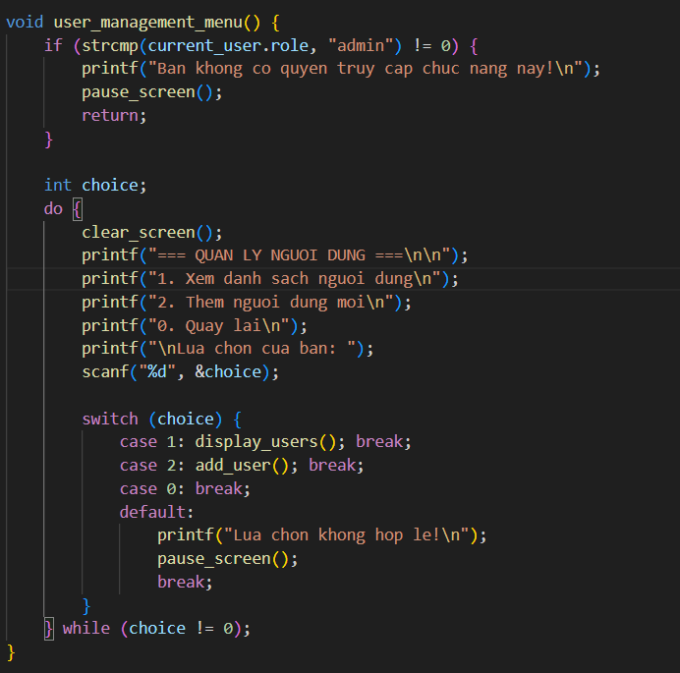

6.2. Inventory Management
- Tracks product details: ID, name, quantity, price, category, and warehouse location.
- Functions:
- View inventory list.
- Add new products.
- Update stock quantity.
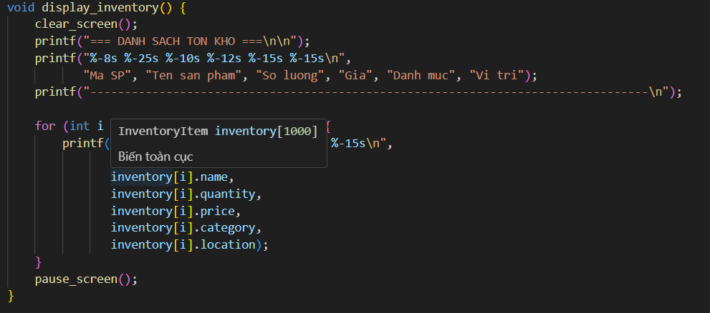

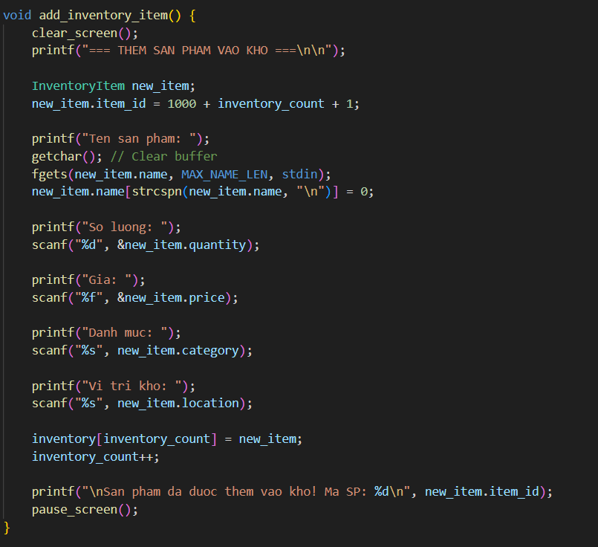

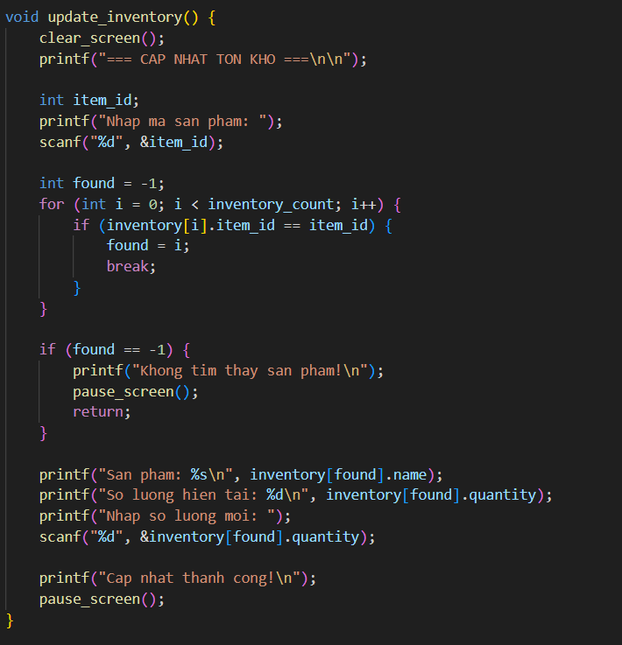

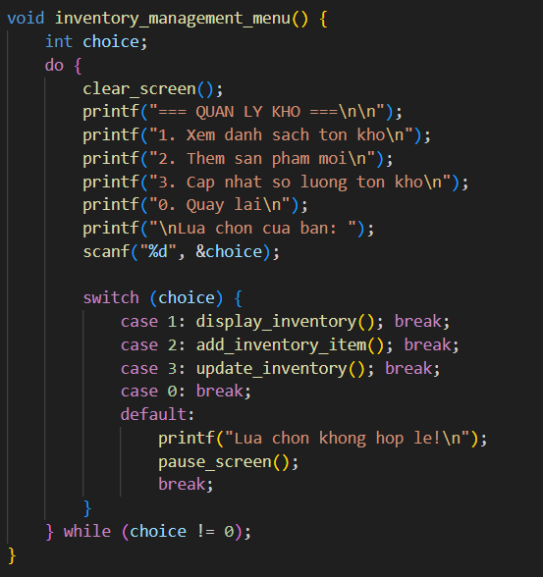

6.3. Order Management
- Each order includes customer info, product, quantity, status, order date, and assigned vehicle.
- Functions:
- Add new orders.
- View order list.
- Update order status: pending, processing, shipped, delivered.
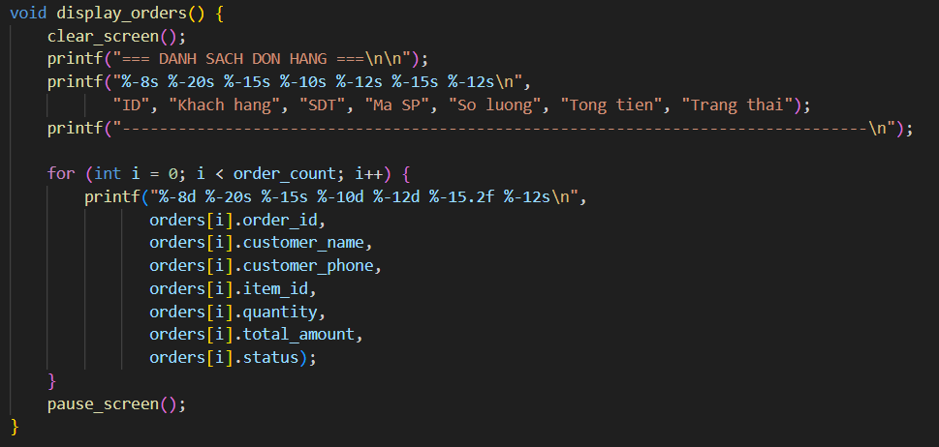
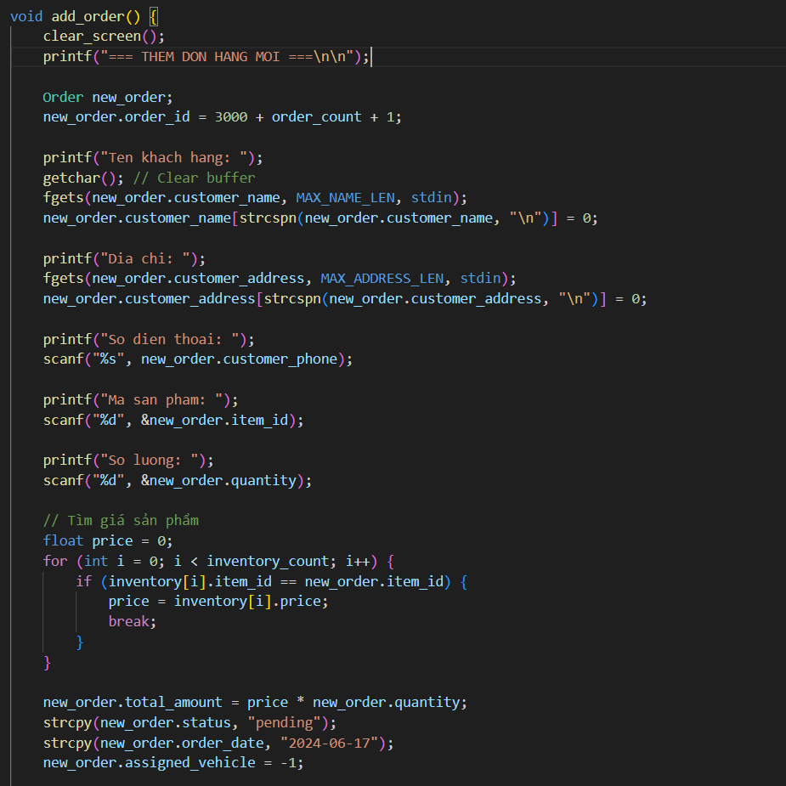
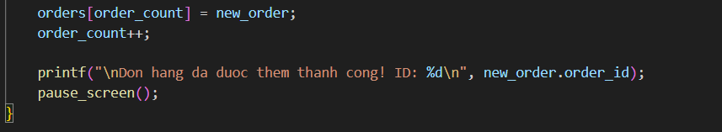
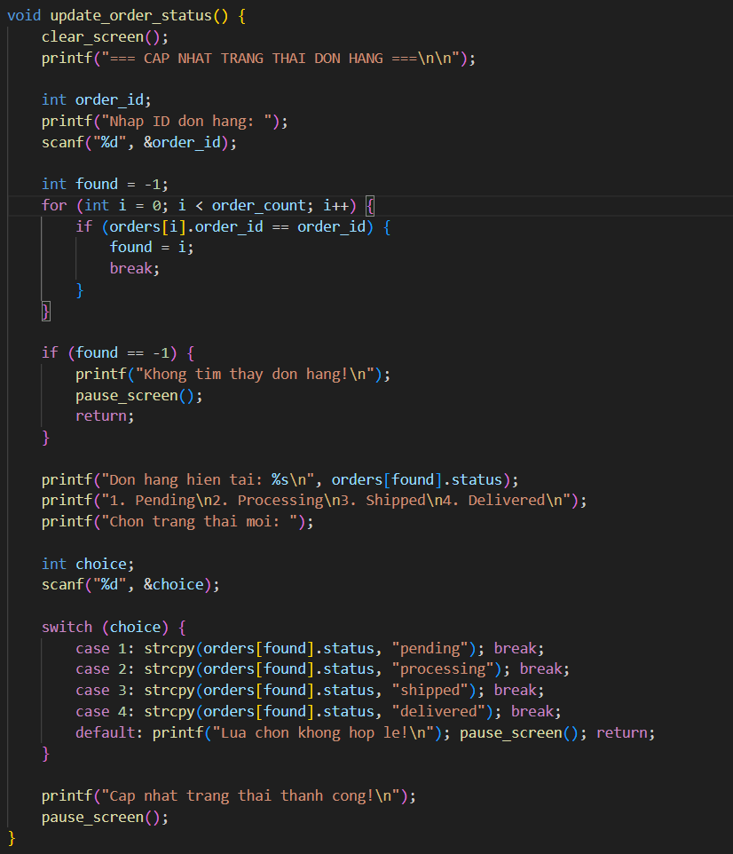

6.4. Vehicle Management
- Manages delivery vehicles such as trucks, vans, and motorcycles.
- Data includes type, license plate, capacity, driver, and status (available, busy, maintenance).
- Functions:
- Add new vehicles.
- Update vehicle status.
- View vehicle list.
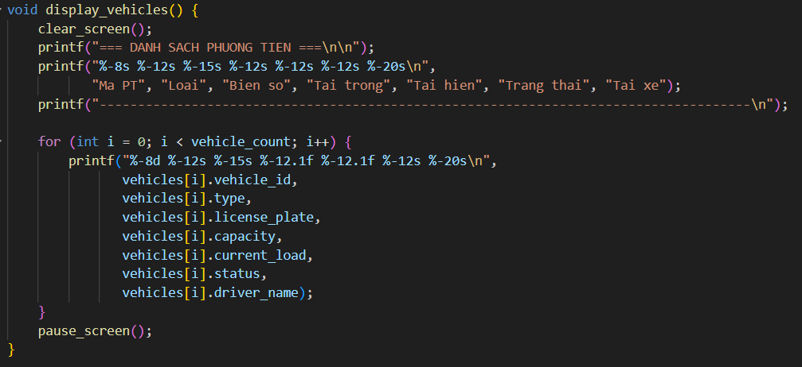

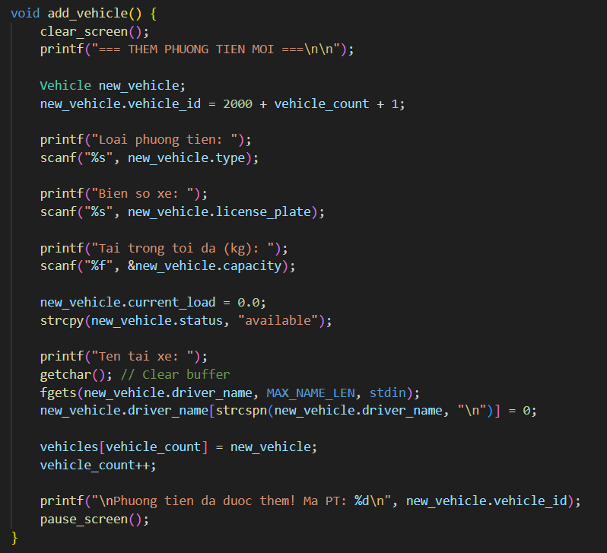

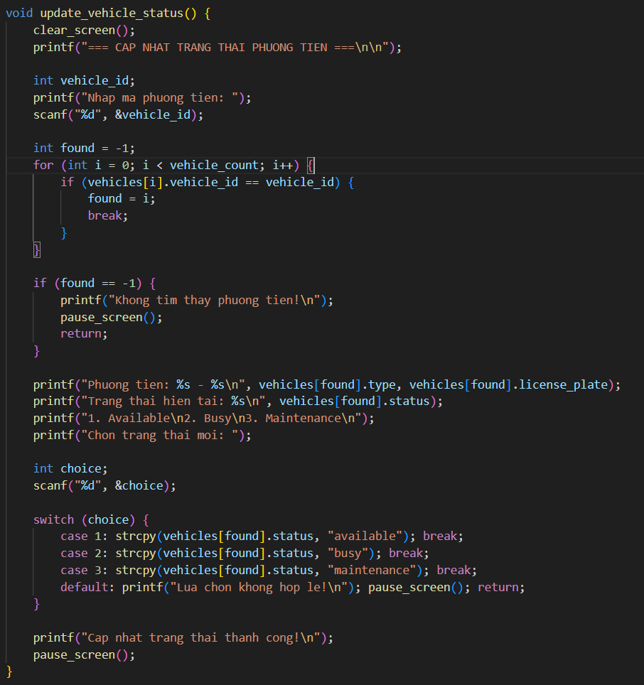

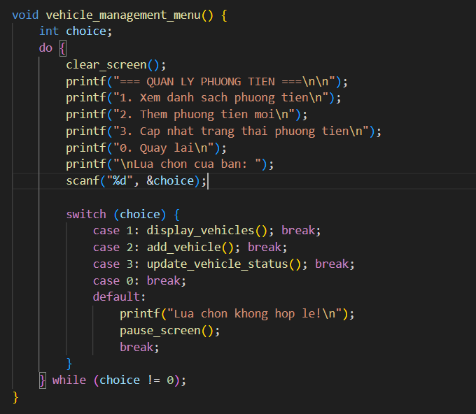

6.4. Route & Delivery Management
- Stores delivery routes: start/end location, vehicle, distance, and estimated time.
- Functions:
  - Create new delivery routes.
  - Assign orders to routes (and update statuses).
  - View route list.
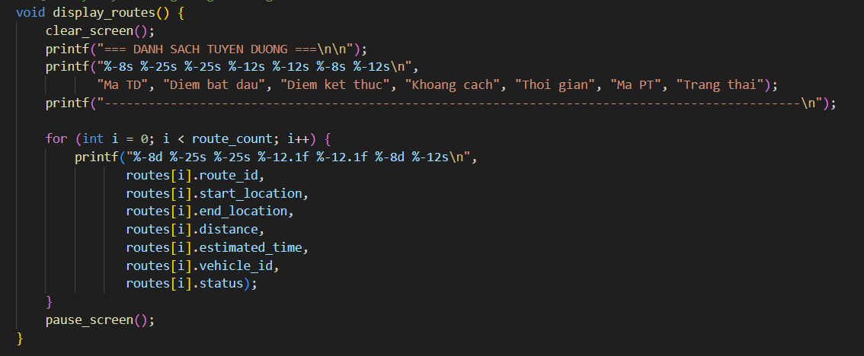

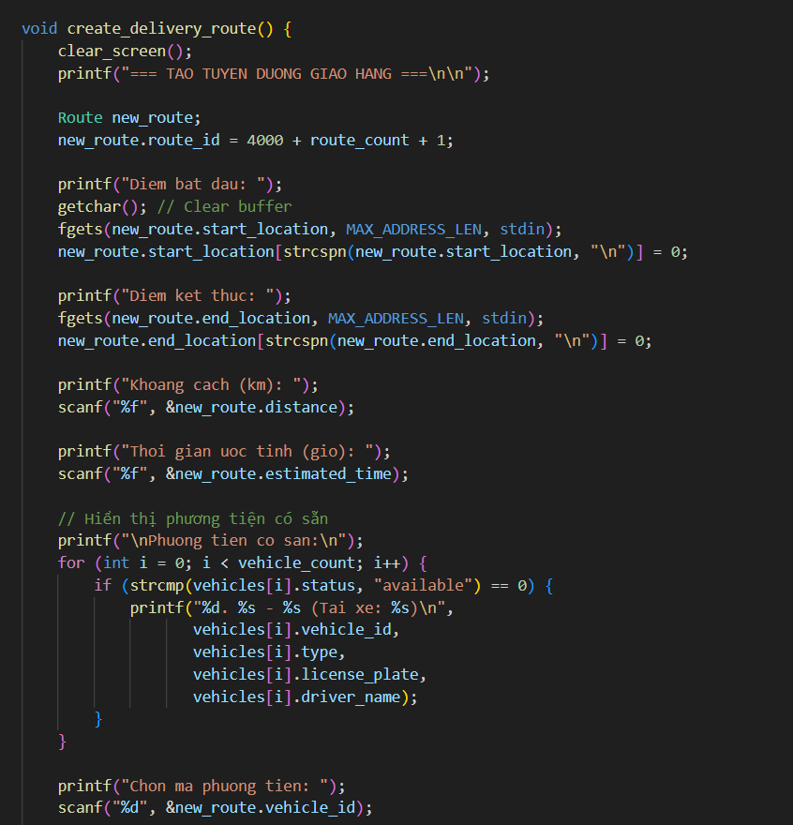
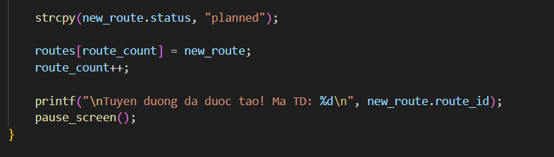

6.5. Reports and Statistics
- Provides reports on:
- Inventory (total value, low-stock items).
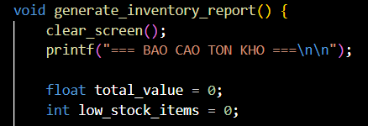
void: This function does not return any value.
generate_inventory_report(): The function name means “generate inventory report”.
Declares a variable total_value of type float, used to store the total value of inventory, initialized to 0.
Declares a variable low_stock_items of type int, used to count the number of low-stock items, initialized to 0.

- Orders (by status, total revenue).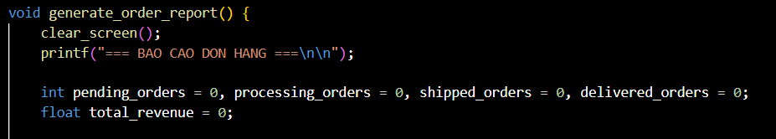
- void: The function does not return any value.
- generate_order_report(): The function name means “generate order report”.
Declares four integer variables to count orders by status:
- pending_orders: orders that are pending.
- processing_orders: orders currently being processed.
- shipped_orders: orders that have been shipped.
- delivered_orders: orders that have been delivered.
All are initialized to 0.
Declares a float variable total_revenue to store the total revenue generated from the orders.
Initialized to 0.

- Vehicles (availability, load usage rate).
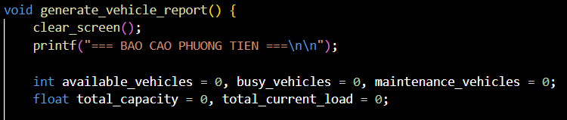
void: The function does not return any value.
generate_vehicle_report(): The name of the function means “generate vehicle report”.
Declares three integer variables:
- available_vehicles: Number of vehicles that are currently available.
- busy_vehicles: Number of vehicles that are currently in use.
- maintenance_vehicles: Number of vehicles under maintenance.
All initialized to 0.
Declares two floating-point variables:
- total_capacity: The total carrying capacity of all vehicles.
- total_current_load: The current total load being carried by the vehicles.
Both initialized to 0.

6.6. Search and Filter
- Search orders by ID, customer name, or status.
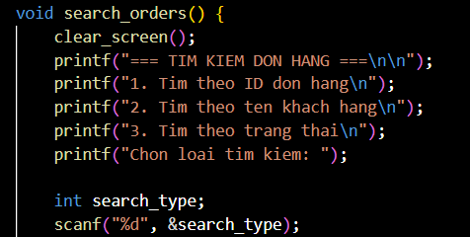
The function is named search_orders() and returns no value (void).
It begins by clearing the screen using the clear_screen() function.

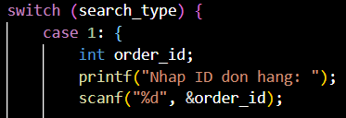
Prompts the user to enter the order ID
Stores the input in the variable order_id.
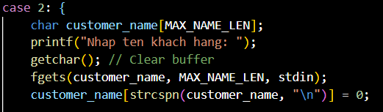
Declares a string customer_name with maximum length MAX_NAME_LEN.
Uses getchar() to clear any leftover newline from the buffer.
Uses fgets() to read the full customer name (including spaces).
Removes the newline character (\n) at the end of the string using strcspn.

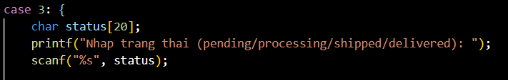
Declares a string status.
Prompts the user to enter the order status (e.g., pending, processing, etc.)
Reads the input using scanf.

- Search inventory by ID, name, category, or filter low-stock items.
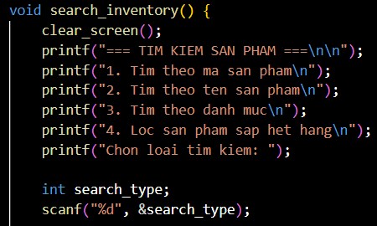

The function is called search_inventory() and returns no value (void).
clear_screen() is called to clear the terminal screen for better display.
Declares search_type to store the user's menu choice.
Reads input using scanf.

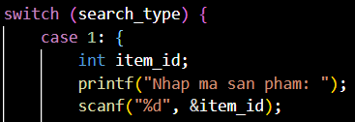
- Declares variable item_id for storing product ID.
- Prompts and reads product ID from user.
- Vehicles (availability, load usage rate).

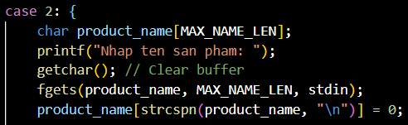
Declares a string product_name with length MAX_NAME_LEN.
Uses getchar() to clear the newline from the buffer.
Uses fgets() to safely read product names (including spaces).
Removes newline (\n) from the input string.

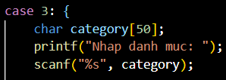

Declares category string of length 50.
Prompts user to enter product category.
Uses scanf() to read the category.

RESULT
When running the program, the terminal will display:
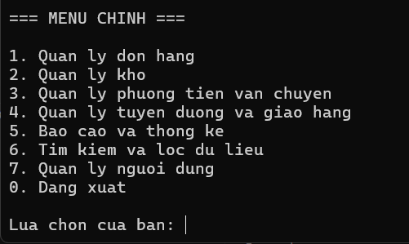
- Choose 1:
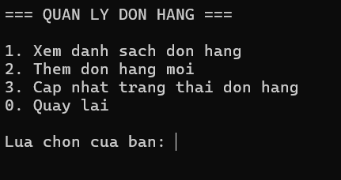
- Choose 2:
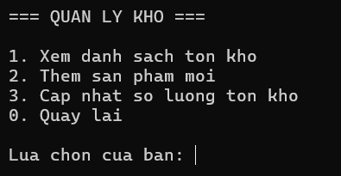
- Choose 3:
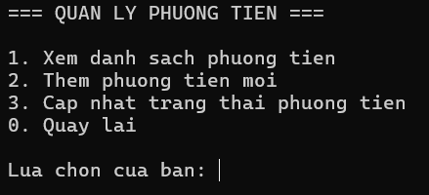
- Choose 4:
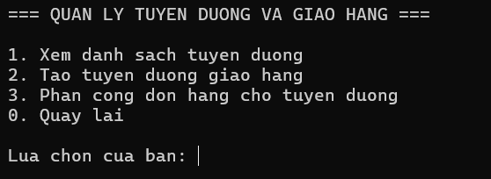
- Choose 5:
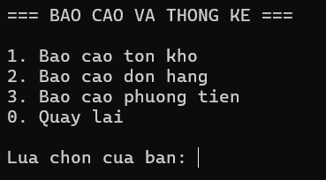

- Choose 6:
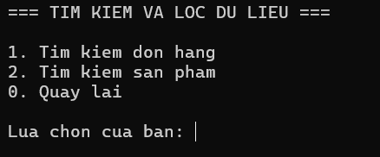
- Choose 7:
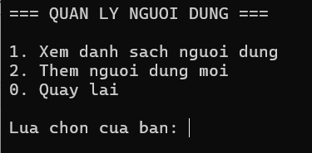

CONCLUSION
The development of the Logistics Management System using the C programming language demonstrates the practical application of core data structures and algorithms. Throughout the process, we designed and implemented features that simulate real-world logistics operations, including order tracking, warehouse inventory management, vehicle scheduling, route assignments, user role control, and reporting functionalities.
This project allowed us to consolidate our understanding of array-based storage, structured programming, and console-based interfaces. By building the system from scratch, we strengthened our algorithmic thinking and improved our ability to organize complex logic into modular, maintainable code.
Despite limitations such as the use of static arrays and in-memory storage only, the system fulfills its educational purpose and lays a solid foundation for future enhancements such as file persistence, database integration, or graphical user interfaces.
In conclusion, this project not only reinforces our knowledge of data structures but also provides a valuable experience in software design, making it an ideal capstone for the Data Structures and Algorithms course.

